Process Documentation

Created by: Team member 1

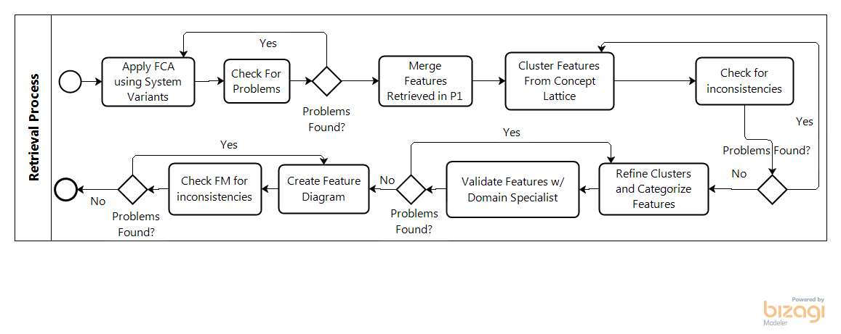

|  |  |
| --- | --- |
| Activity: | Apply FCA using System Variants Source Code |
| Member Responsible: | Team Member 1 |
| Generated Artifact: | Concept Lattice |

|  |  |
| --- | --- |
| Activity: | Check For Problems |
| Member Responsible: | Team Member 2 |
| Generated Artifact: | Concept Lattice, Problems List |

|  |  |
| --- | --- |
| Activity: | Cluster Features from Concept Lattice |
| Member Responsible: | Team Member 1 |
| Generated Artifact: | Cluster Tree |

|  |  |
| --- | --- |
| Activity: | Merge Features Retrieved in P1 (Phase 1) |
| Member Responsible: | Team Member 1 |
| Generated Artifact: | Cluster Tree |

|  |  |
| --- | --- |
| Activity: | Check for inconsistencies |
| Member Responsible: | Team Member 2 |
| Generated Artifact: | Cluster tree, problems list |

|  |  |
| --- | --- |
| Activity: | Refine Cluster and categorize features |
| Member Responsible: | Team Member 1 |
| Generated Artifact: | Refined Cluster, Feature information report |

|  |  |
| --- | --- |
| Activity: | Validate Features w/ domain specialist |
| Member Responsible: | Team Member 2 |
| Generated Artifact: | Feature information report |

|  |  |
| --- | --- |
| Activity: | Create Feature diagram |
| Member Responsible: | Team Member 1 |
| Generated Artifact: | Feature diagram |

|  |  |
| --- | --- |
| Activity: | Check FM for inconsistencies |
| Member Responsible: | Team Member 2 |
| Generated Artifact: | Feature diagram |